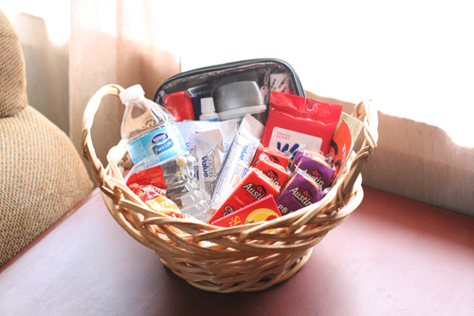

Clemons Library, 4th Floor

Spanish House (Casa Bolivar)

Lambeth Residence Area

Kabob Palace ($$ donations only)

Saturday 10/25 – Tuesday 12/2

## The VAA will be collecting socks, Kleenex pocket tissues, moist/antibacterial wipes, mouthwash/gum, gift cards to take-out eateries or grocery stores, bottled water, granola bars and other snacks, chapstick, sanitary products (soap, toothpaste & brushes, deodorant, etc.), and small winter garments (hats, gloves, scarves, etc.) from mid-October to mid-November. Help us give a little help and hope to those in our community who are struggling even for the simple things in life. Drop of your donations at the locations listed below!

# Help the Virginia Atheists and Agnostics spread some comfort this Holiday Season!

**Care Packages for the Needy!**

**A Drive for the Homeless and Very Poor**

Virginia Atheists and Agnostics

[Virginia-Atheist@virginia.edu](mailto:Virginia-Atheist@virginia.edu)

Find us on Facebook!