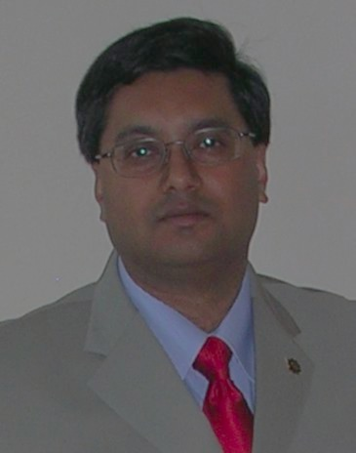

Dr. Dinesh Singh, a follower of the Bahá’í Faith and physicist who specializes in the study of gravitation and Albert Einstein’s theory of general relativity, will explore the “New Atheism” proposed by Richard Dawkins and discuss how belief within science is not fundamentally different from belief within religion.

✹

# Theoretical Physicist from the University of Regina (Saskatchewan, Canada)

## Dr. Dinesh singh

# The UVA Bahá’í Association and the Charlottesville Bahá’í Community present

january 31, 2013

7- 9PM newcomb hall kaleidoscope room

✹

Belief in science and belief in god