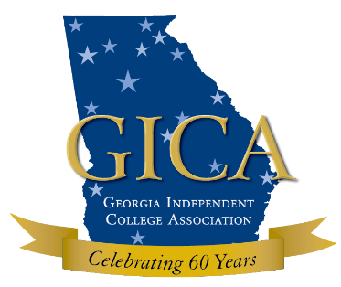
Position Description
Healthy Campus Project Officer

Title: Healthy Campus Project Officer
FLSA: Exempt
The Healthy Campus Project Officer (HCPO) reports to the Compliance Program Director (CPD) and provides leadership, education and consultation to the Georgia Independent College Association (GICA) in support of 12 colleges and universities from GICA, the University System of Georgia (USG) and the Technical College System of Georgia (TCSG) who are participating in projects to promote a healthy campus community and prevent sexual and interpersonal violence. The HCPO will assist with the establishment and leadership of the Healthy Campus Coalition (HCC) and its various activities with its members, which includes members of GICA, USG and TCSG. This position is grant-funded by the grantor (August 1, 2016 – June 30, 2019).
Responsibilities:
- Assists public and private colleges and universities in formation of Healthy Community Taskforces (HCTF) and Sexual Assault Response Teams (SART)
- Assists HCTF and SART members at public and private colleges and universities in implementing primary prevention strategies and environmental change initiatives related to sexual assault and alcohol abuse
- Conducts training sessions on assessment and capacity building for HCTFs
- Assists CPD in coordinating 4-6 trainings annually on sexual assault issues
- Works closely with HCC Leadership Team to implement HCC goals and objectives
- Organizes six yearly meetings/trainings for HCC
- Communicates with HCC members on a regular basis through e-mail, newsletter and website
- Recruits prevention personnel at colleges and universities in Georgia for membership in HCC
- Negotiates contracts with various entities to secure lodging, food and other logistical requirements for the work of HCC
- Assists GICA Director of Research with HCC Research Conference
- Works with appropriate state and national associations and agencies on prevention projects
- Ensures compliance with all sexual assault policy and prevention grant awards
- Coordinates and assembles all quarterly reports as required by granting agencies
- Researches potential funding opportunities and assists with grant writing and reporting in order to ensure sustainability of HCC and this position
- Local, state and national travel required

Qualifications:
- Master’s degree in Public Health, Health Education or related field or significant work experience with a major emphasis on violence and/or substance abuse prevention in a higher education setting
- Demonstrated knowledge and application of primary prevention, program planning and implementation
- Knowledge of Title IX and Violence Against Women Act regulations
- Highly effective organization and communication skills
- Demonstrated collaboration skills and expertise in population level change
- Demonstrated ability and interest in engaging in culturally-sensitive services to and collaboration with a diverse group of institutions of higher education
- Certified Health Education Specialist (CHES) or CHES-eligible preferred
- Candidate must be proficient in MS Excel, Word and PowerPoint

Additional Knowledge, Skills and Abilities:
- Interact effectively and professionally with a diverse group of people
- Effective written and oral communication skills
- Must be flexible and prepared for unanticipated tasks
- Strong organizational skills with ability to manage multiple tasks simultaneously and meet deadlines
- Ability to work in a team environment and maintain confidentiality

Work Environment/Physical Demands: Normal office environment, typically sitting at desk, use of office equipment, walking or standing. Ability to lift approximately 40 pounds and carry for up to 20 feet required. Travel away from the office to an event and the need for occasional overnight travel is required. Some driving may be needed. Ability to access stored documents and office supplies weighing up to 20 pounds requiring use of step ladder up to three feet long required.

Application Process: Interested, qualified individuals should submit a cover memo speaking to the candidate’s qualifications, a current resume, and a completed GICA employment application form to humanresources@georgiacolleges.org. The position is open until filled.

This job profile is intended to be generic in nature. It is not intended to specify all duties and responsibility of any particular position. Additional job functions and the need to work a flexible work schedule may vary based on specific requirements of an event or task.

