Program Details/Picture

- Wellness Wheels:
We drove around campus in a golf cart asking students if they wanted a ride. If they said yes, we gave this spill, “HI, my name is _______ and I’m a counselor on campus. This is Sexual Assault Awareness Month. Would you be willing to answer some questions on this topic for some prizes until we reach your stop?” Then we asked them questions about sexual assault/bystander intervention until we arrived at their destination and then gave them a prize. Prizes usually had some resource for sexual assault. We usually do this in April (Sexual Assault Awareness Month), one day a week- like every Tues. or Wed. of the month.

Question Examples:
1. Every ___ minutes someone is sexually assaulted in the US? (2 minutes)
2. What is the percentage of women that will be sexually assaulted in their lifetime? (1 in 4-6)
3. What % of college women will be assaulted? (1 in 4)
4. What percent of rapes involve a weapon? (7%)
5. T or F- About 75% of rapes are committed by someone the victim knows. (T)
6. How could you help a friend that told you he or she has been sexually assaulted?
7. Where on campus could they go for help?
8. What could you do if you saw a friend being dragged upstairs by someone he or she does not know and they are wasted?

- Hands are not for Hurting:
Supplies: White bed sheets, water resistant paint, paint pans/brushes, sharpies
We would set up a table in our student center and ask students to take a pledge that their hands were not for hurting. If they agreed, they would paint one of their hands and add it to the sheet. They could write their names if they wanted to. After it dried, we hung the project in a very visible place on campus.

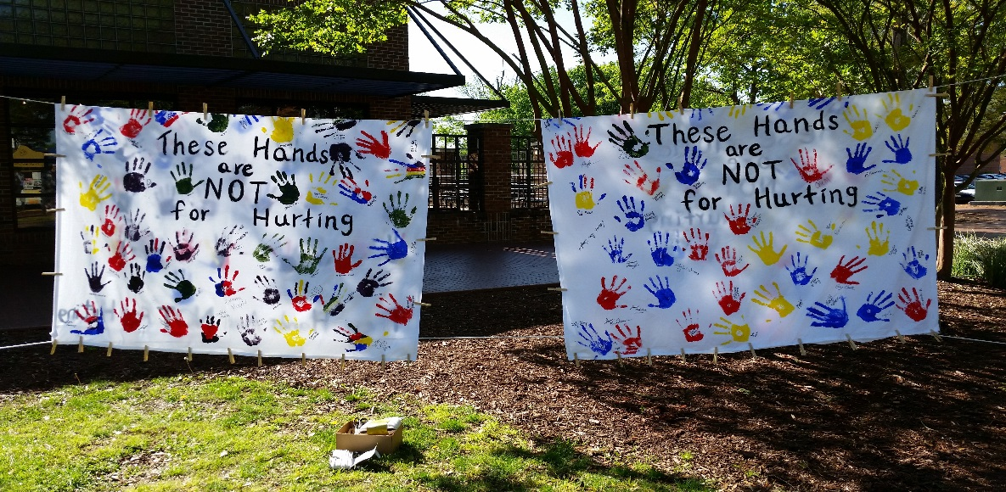

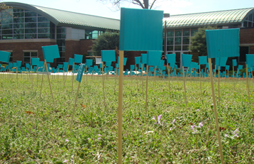
- Teal Flag Display:
Set up the amount of flags on our main
lawn that represent the number of women
who would be sexually assaulted while in
college based on our student population.
For us, this number was 972. We put 972
flags out on the lawn and signs around
the display, letting others know the statistics
and our contact information at the
counseling center.

