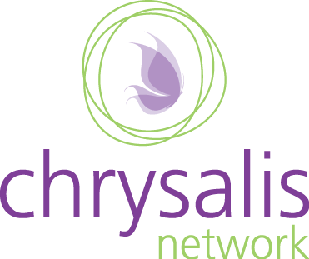
Call for Proposals

Solving the Campus Sexual Assault and Dating Violence Puzzle: How to Understand and Take Action on New Federal Requirements

December 16 & 17, 2014
Meredith College
Raleigh, NC

- Employee Training
- Engaging Men
- First-year Programming
- Peer Education
- Program Evaluation
- Response Protocols & Confidentiality
- Student Conduct/Disciplinary Processes
- Survivor Rights

We invite practitioners, researchers, advocates, activists, preventionists, and other professionals to submit proposals for conference presentations. We are particularly interested in proposals from administrators, staff and faculty working on North Carolina campuses, however we are accepting proposals from other professionals, and those outside of North Carolina.
We are interested in presentations that illustrate Campus SaVE requirements including innovative approaches to primary prevention. Proposals focusing on marginalized populations, Historically Black College and Universities, and community colleges are strongly encouraged. Each workshop will be 90 minutes in length. We are particularly interested in proposals from the following topic areas:
- Awareness Campaigns
- Bystander Interventions
- Campus Climate Assessment
- Campus Policy
- Campus Response Teams
- Comprehensive Prevention Plans
- Dating Violence and Stalking Programs
- Defining Consent
www.chrysalisnetwork.com
Guidelines for submitting proposals:
- Proposals that focus on skill development, practical application, lessons learned/results, and data-driven strategies and programs are encouraged.
- Proposals for interactive workshops are encouraged.
- Proposals must be developed for a 90-minute workshop.
- Proposals are due by Monday November 3rd, 2014.
- Proposals must be submitted via email to: Juliette Grimmett Juliette@chrysalisnetwork.com. Please put “Solving the Puzzle Workshop Proposal” as the Subject Line.
- For any questions, please contact Juliette at (919) 624-9575 or Juliette@chrysalisnetwork.com.
- Proposal submission does not guarantee workshop acceptance.
- Presenters will be notified of acceptance status via email by Friday November 14th, 2014.
- If your proposal is accepted, up to two presenters will receive discounted conference registration.
Request for Proposal:
Solving the Campus Sexual Assault and Dating Violence Puzzle: How to Understand and Take Action on New Federal Requirements

Please note that all information provided will be included in the conference program and marketing materials unless otherwise specified by presenter(s).
A. Contact information for Primary Presenter (please provide all of the following information for each presenter):
Name: __________________________________________________________________________
Campus/Organization: ______________________________________________________________
Job Title: __________________________________________________________________________
Address: __________________________________________________________________________
Phone: __________________________________________________________________________
Email: __________________________________________________________________________

B. Contact information for second presenter:
Name: __________________________________________________________________________
Campus/Organization: ______________________________________________________________
Job Title: __________________________________________________________________________
Address: __________________________________________________________________________
Phone: __________________________________________________________________________
Email: __________________________________________________________________________
C. Workshop Title:

D. Narrative: In the space below, please provide a 400-word or less descriptive narrative for your workshop. The narrative should identify the basic message of the workshop and how you will make the workshop interactive.
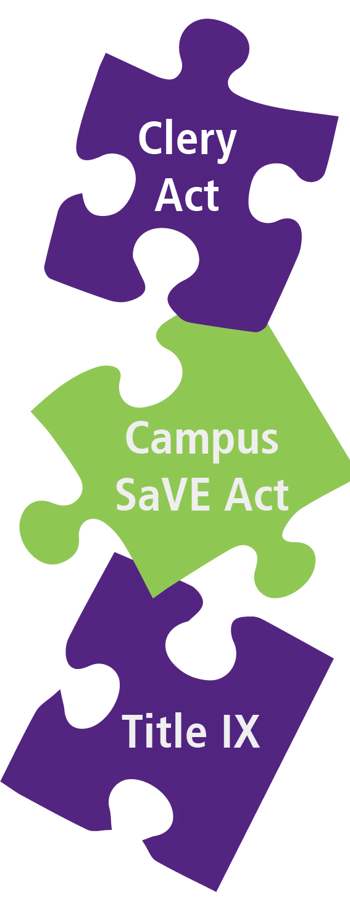

E. If applicable, please check up to two categories that your presentation covers:

- Awareness Campaigns
- Bystander Interventions
- Campus Climate Assessment
- Campus Policy
- Campus Prevention Teams
- Campus Response Teams
- Comprehensive Prevention Plans
- Dating Violence and Stalking Programs
- Defining Consent
- Engaging Men
- First-year Programming
- Peer Education
- Program Evaluation
- Response Protocols & Confidentiality
- Student Conduct/Disciplinary Processes
- Survivor Rights
- Other: ___________________________

F. Please list at least 3 learning objectives for your session:

G. Short Description: Please provide a brief (less than 150 words) description of your workshop that could be used in publicity materials, including the conference program.

H. Presenter’s Bio(s): Please include a bio of 150 words or less for each presenter.

I. AV Needs and Supplies: Please indicate your needs:
- Flipchart & Markers
- Laptop
- LCD Projector
- Screen
- Speakers
- Other: _____________________________________________________________________________

Sponsors: Appalachian State University, Johnson C. Smith University, Meredith College, UNC-Chapel Hill, Wilkes Community College, William Peace University, Wilson Community College and the NC Coalition Against Domestic Violence and the NC Coalition Against Sexual Assault.

Thank you for your interest in sharing your work with the North Carolina campus community.
We will be in touch by Friday November 14, 2014.

www.chrysalisnetwork.com

